LEGOLAND® Windsor Resort
School Information Pack

Contents

Schools - Important information 2
Lead Teacher Checklist 3
BEFORE I PAY 3
BEFORE MY VISIT 3
AFTER MY VISIT 3
Risk Assessment Form: LEGOLAND® Windsor Resort 4
Ride Ratios and Restrictions 8
Information Sheet 9
Permission Slip 10
BACS Payment Processing Form 11

Schools - Important information
Teachers:
For queries about your visit, workshop content or if you need support on the day, please contact the schools team at school.enquiries@legoland.co.uk or call 01753 626415.
Tickets:
Tickets can be collected from the Ticket Office upon arrival at the resort. Just show your booking reference and school I.D.
Coaches and mini-buses:
Coaches and mini-buses can park for free in car park C.
Annual Passes:
Students with a valid Annual Pass will usually be admitted to the resort for free but will be subject to normal Annual Pass holder conditions.
Toilets:
Upon arrival, the nearest toilets are to the left of the turnstiles before you enter the Resort. During Educational Workshops, the nearest available toilets are the public toilets opposite the Education Centre.
Education Workshop Directions:
If you have booked an Educational Workshop it will be in the Imagination Area. There are signs for this around the resort. From The Beginning keep to the left and head down the hill to follow the path down to Imagination. The Education Department is opposite the 4D theatre on the right.
Workshop late arrivals:
If you are running late for a workshop, please call the Schools team on 01753 626415 and we will do our best to fit you in, however this is subject to availability.

Lead Teacher Checklist
IMPORTANT: Please ensure THE TEACHER VISITING on the trip has this checklist ASAP!

BEFORE I PAY
Check the booking confirmation: We will prepare for your trip based on the details of your booking confirmation email. Please make sure it’s correct before payment. If anything needs amending, please call 01753 626415 or email school.enquiries@legoland.co.uk.
Make payment at least 10 days before your trip: You can pay by calling 01753 626415; by BACS download your BACS form here or by postal cheque to LEGOLAND Windsor Resort, PO Box 170, Chessington, Surrey, KT9 9AF. Please note: If payment is not received in this time, you may lose your allocation for tickets/workshops.
P.S. If you need to cancel the booking for any reason, please email school.enquiries@legoland.co.uk so that we can release your tickets for another school to use.

BEFORE MY VISIT
Resources: Download your free risk assessment and public liability document by visiting our ‘Planning’ page here.
Planning visit: Plan a date with your school to conduct a planning trip visit. You can collect two free planning tickets at the Ticket Centre after payment has been received for your trip.
Check opening times: Make sure you are arriving on time. Check out open times by clicking here.
Check parking and directions: by clicking here.
What you need to bring: Make sure you have your booking reference number to collect them from our ticket office! Please bring your key contact information forms that can be found at the bottom of this document.

AFTER MY VISIT
VAT: Call 01753 626415 to request trip VAT receipt if required. This will be posted out to you within a few days.

Risk Assessment Form

With over 55 interactive rides, live shows and attractions, all set in 150 acres of beautiful parkland; bring learning to life outside of the classroom with our tailored school trips which can engage, excite and inspire your students. Whether you choose to self-lead or take part in one of our unique workshops you will find LEGOLAND is a truly unique learning experience.

LEGOLAND Windsor Resort has been awarded with a Learning Outside of the Classroom Quality Award: a national accreditation for the provision of learning.

About Merlin Entertainments Group Ltd
Merlin Entertainments is the largest European entertainments company operating in Europe. Merlin runs 99 attractions in 22 countries across four continents. Our aim is to deliver unique, memorable and rewarding experiences to millions of visitors across our growing estate. We believe that we achieve this objective largely thanks to the commitment and passion of our team and the strength of our brands, which will never fail to be distinctive, challenging and innovative.

Behaviour

Misbehaviour: | The attraction has regulations displayed at the entrance. Staff members are trained to enforce these regulations for the benefit of all of our Guests. Staff will instruct children to behave where necessary. Please note that children under the age of fourteen must be accompanied by an adult at all times, this is non-negotiable. Staff will challenge any child without sufficient supervision and will take them to Heartlake City Sensory Zone to be reunited.

Legal Requirements and Attraction Information
Public Liability: | LEGOLAND is covered by Public Liability and the policy is with CHUBB Insurance
Local Enforcement Agency: | Royal Borough of Windsor and Maidenhead
Rides Engineering/Maintenance: | Fairground and Amusement Parks – Guidance on safe practices HSG 175
Food safety and hygiene: | All food outlets operate in accordance with the Food Safety Act 1990. They are regularly inspected by the local Environmental Health Department
Attraction Staff/Identification: | All staff wear uniform or are easily identifiable from their LEGOLAND Windsor ID worn on lanyards around their neck. Full Standard Declaration Questionnaires are carried out on all staff employed at the Attraction
Security: | The attraction has a dedicated security team who are able to deal with minor security issues on site. The team are also trained to deal with any emergency situations that may arise.

Risk Assessment

Vehicle traffic: | The attraction is closed to vehicular traffic movement whilst open to the public. There are designated drop-off points for coaches at LEGOLAND in Coach Park C. There is no requirement for children to cross any busy public roads although children will be required to cross internal park roads to access the admissions area and in the case of special occasions – St. Leonards Mansion. Pedestrian walkways are provided with all steps having alternative flat access.
Weather Protection / Sun safety: | There is not a great deal of cover in the Resort, please be prepared for rain at all times and wear sensible flat footwear due to the undulation of the Resort and the need to brace on several of our rides. There are shaded areas provided throughout the attraction for sunny weather.
Water: | All public areas are fenced off to prevent access to water. Some rides at the attraction do expose children to water by riding in boats or pods such as Raft Racers, Pirate Falls, Viking River Splash and S.Q.U.I.D Surfers. There is a water play area located in DUPLO Valley. All water used in the Resort is either fresh from pipes or treated by chlorination.
Slips/Trips/Falls: | The following should be noted:  - Wet flooring,  - Steep slopes,  - Steps and stairs,  - Boarding and disembarking rides
High Level Areas: | The Resort is situated on the side of a hill, Guests can see over the area before making their way down to the bottom of the park. A Hill train can transport Guests from the top to the bottom or vice versa. Handrails are provided where necessary. There are no steep slopes at the Resort. Due to the nature of the Resort being situated on slight hills, scooters, roller skates and children's tricycles are not permitted into the Resort. For their own safety we request that children wearing Wheel Heeled shoes (Heeleys) do not activate the wheel part of the shoe and take due care and attention whilst in the Resort.
Strobe Lighting: | The Dragon Coaster has a small amount of strobe lighting.
Reduced Lighting | A few attractions feature reduced lighting. This information can be found on the signage at the entrance to each ride.
Enclosed Spaces: | Some of the Rides & Attractions can be quite small in area and to some individuals these might feel contained. However, no area can be defined as a confined space.
Attraction Specific Risk: | Whilst all our rides are maintained to the highest safety standards and our staff are trained to operate them, we recommend that all safety notices displayed or on the Resort Guide are read before entering
Rides: | All safety instructions must be obeyed. Rides undergo rigorous testing every day by competent engineers in accordance with manufacturer guidelines. Beware of closing doors on fingers
Play equipment: | There are a number of unsupervised play areas in the Resort, all equipment conforms to the current British and European standards but supervision is required.

Attraction Arrangements

Arrival Arrangements | There are designated drop-off points for coaches at LEGOLAND in Coach Park C.
Parking | There is ample car / coach parking facilities available.
First Aid: | The First-Aid facility is located in Heartlake City; qualified first aiders are always on hand to help. Should you need assistance, please make contact with any member of staff.
Emergency Planning: | LEGOLAND has a contingency plan in the event of an emergency. The emergency plan has been developed in conjunction with the local emergency services, whom we have regular meetings regarding emergency procedures and planning.
Fire Safety: | In the event of an emergency please follow all displayed evacuation procedures and listen to instruction from members of the LEGOLAND team.
Wheelchair Access: | LEGOLAND has been designed with the needs of Guests with disabilities firmly in mind – the Resort is more than 95% accessible to wheelchair users. The paths are level and suitable for wheelchairs; however it can be steep in sections and may require additional assistance.
Attraction Wheelchair Access: | For a comprehensive guide to LEGOLAND for Guests with disabilities; please follow this link: http://www.legoland.co.uk/Plan/Guests-With-Disabilities or pick up a guide at Guest Services.
Lost Children: | Lost Child wristbands are available from Ticket Collection and Guest Services on entrance; we strongly recommend that all children in groups are given a contact number for our staff to use should they become separated from the group for whatever reason. If a child is lost, they should make contact with any member of staff who will take them to Heartlake City Sensory Zone or the Beginning Guest Services as a reuniting point.
Age/Height Restrictions: | For a comprehensive list of age and height restrictions on all of our rides and Attractions, please follow this link; https://www.legoland.co.uk/tickets-and-passes/school-bookings/plan-your-trip/
Lockers: | Lockers are available onsite on a first come first served basis and are located at the Beginning, the Imagination Centre and LEGO City. Lockers require a non-refundable £2 coin.
Eating Facilities: | There are many food and drinks establishments within the attraction serving a variety of both hot and cold refreshments. There are also adequate outdoor grounds to picnic within. There is also a lunch room available for schools to use on a first come, first served basis between 12 and 2pm. It is located next to City Walk Pizza and Pasta
Welfare Facilities: | There are toilet blocks within every area of the Resort, each with a wheelchair accessible toilet.
Additional Costs | There are several outlets around the Resort serving snacks and drinks. Some attractions such as Gold wash cost extra.
Attraction Signposting | The Resort is well sign-posted. Also, Resort maps are issued to all adults and teachers who are supervising the school trip. In order to avoid queuing or to check queue times throughout the day please download the Legoland app.
Smoking | Smoking is now only permitted at designated areas throughout the park. These are highlighted on the park map.

Ride Ratios and Restrictions

Lands | Ride | Height/Age Restrictions | Ratio (Teacher to Student)
Kingdom of The Pharaohs | Laser Raiders | Under 1.3m must be accompanied by an adult | 1:3
 | Scarab Bouncers | Minimum Height of 0.9m | N/A
 | Aero Nomad | Under 1.3m must be accompanied by an adult | 1:4
 | Desert Chase | Under 1.1m must be accompanied by an adult | 1:2
 | Thunder Blazers | Minimum Height of 0.9m | N/A
Adventure Land | Squid Surfer | Minimum 1.0m, Between 1.0m and 1.3m must be accompanied by an adult | 1:1
 | LEGO City Deep Sea Adventure | Under 1.3m must be accompanied by an adult | 1:6
LEGO City | Coast Guard HQ | Under 1.3m must be accompanied by an adult | 1:2
 | Haunted House Monster Party | Minimum of 0.9m to ride and 1.3m must be accompanied by an adult | 1:3
 | Driving School | Aged between 6-13 (cannot be accompanied) | N/A
 | Learner Drivers | Aged between 3-5 (cannot be accompanied) | N/A
 | Fire Academy | Minimum 0.9m, Between 0.9m and 1.3m must be accompanied by an adult | 1:3
 | Balloon School | Under 1.3m must be accompanied by an adult | 1:3
DUPLO Valley | Fairy Tale Brook | Under 1.3m must be accompanied by an adult | 1:3
 | DUPLO Dino Coaster | Minimum 0.9m, Between 0.9m and 1.3m must be accompanied by an adult | 1:1
 | DUPLO Train | Under 0.9m must be accompanied by an adult | 1:3
 | DUPLO Valley Airport | Minimum 0.9m, Between 0.9m and 1.3m must be accompanied by an adult | 1:1
 | Raft Racers | Minimum 0.9m, Between 0.9m and 1.3m must be accompanied by an adult | 1:1
Imagination Centre | Sky Rider | Minimum 0.9m, Between 0.9m and 1.3m must be accompanied by an adult | 1:2
LEGO NINJAGO World | LEGO Ninjago The Ride | Under 1.3m must be accompanied by an adult | 1:3
 | Destiny's Bounty | Minimum 0.9m, Between 0.9m and 1.3m must be accompanied by an adult | 1:3
Land of The Vikings | Viking River Splash | Minimum 1m, Between 1m and 1.3m must be accompanied by an adult | 1:2
 | Spinning Spider | Minimum 0.9m, Between 0.9m and 1.3m must be accompanied by an adult | 1:5
Pirate Shores | Jolly Rocker | Minimum 1m, Between 1m and 1.3m must be accompanied by an adult | 1:4
 | Pirate Falls | Minimum 1m, Between 1m and 1.3m must be accompanied by an adult | 1:3
Knights Kingdom | Knights Quest | Minimum 0.9m, Between 0.9m and 1.3m must be accompanied by an adult | 1:1
 | Dragons Apprentice | Minimum 0.9m, Between 0.9m and 1.3m must be accompanied by an adult | 1:1
 | The Dragon | Minimum 1m, Between 1m and 1.3m must be accompanied by an adult | 1:1
Heartlake City | LEGOLAND Express | Under 0.9m must be accompanied by an adult | 1:3
 | Mias Riding Adventure | Minimum 1.2 meters to ride | N/A

Information Sheet

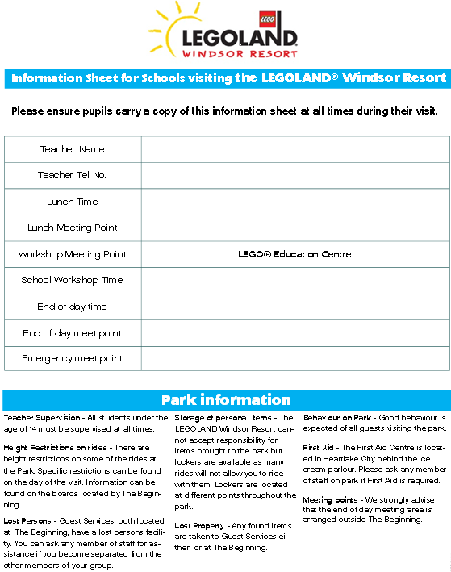

Permission Slip
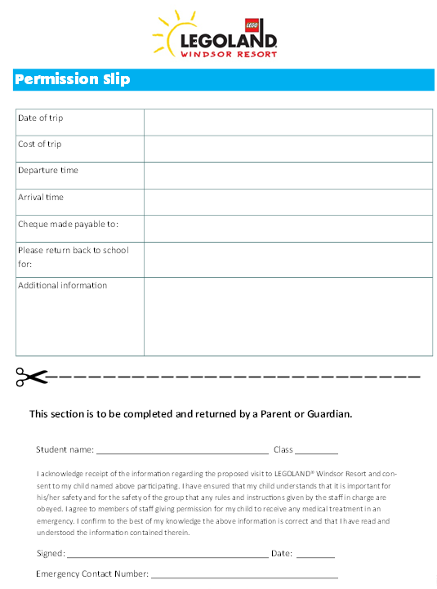

BACS Payment Processing Form

